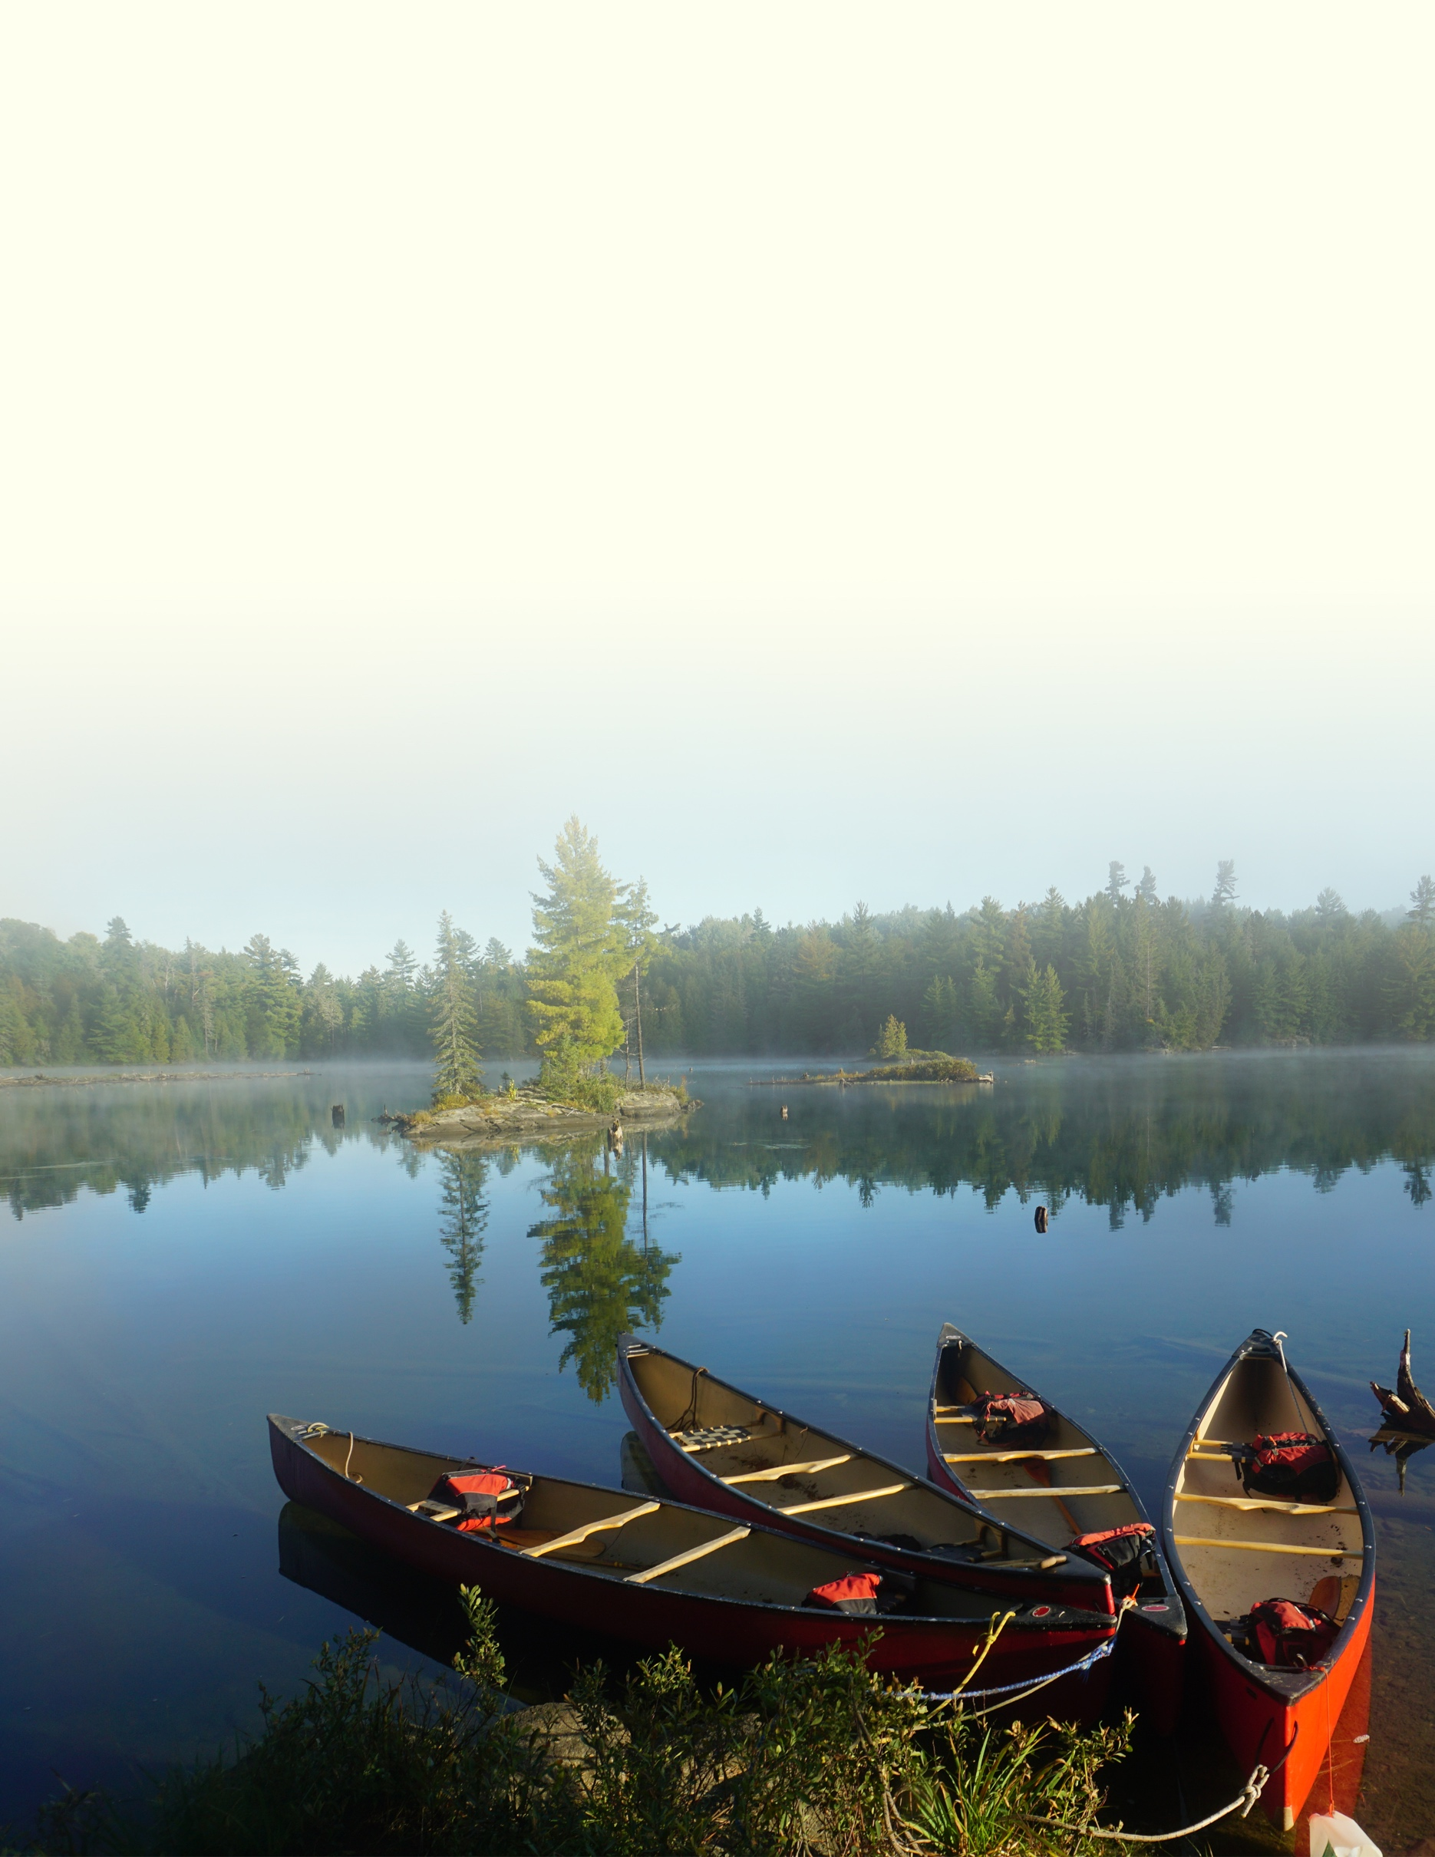

Northwaters Langskib

Outdoor Education Program
for Schools

Table of Contents

Introduction | 1
Course Overview | 2
Overnight | 4
Natural History | 5
Fire Starting | 6
Knot Tying | 7
Voyageur Trip | 8
Maps & Orienteering | 9
Axe & Saw | 10
Paddle Training | 11
Algonquin Trip | 12
Return & Recognition | 13

Introduction

We believe the most significant part of a person's development occurs during adolescence. It is a period of exploration during which young people consider who they are and begin to decide who they want to be. When partnering with schools, it is our aim at Northwaters Langskib to help students through this chapter of their lives by offering safe and nurturing experiences that allow them to learn, experiment, and explore.

We designed the sample program presented here to teach foundational outdoor skills that are applicable in almost all outdoor adventure activities. Each lesson, however, also engages students in a respectful relationship with the natural world. For example, we teach students to collect firewood in a way that limits their impact on the environment around them. We emphasize gratitude for what we take, and for how those resources provide us with what we need to cook, stay warm, and ultimately survive. We draw attention to the intimate connections between our lives and the spaces around us. The curriculum is designed to teach what to do to be successful in the outdoors, but also how to do it so that students are not only tourists, but stewards of the land.

We see our work outdoors as a medium to do work within. When young people learn to steer a canoe in an unforgiving headwind, they encounter their perseverance and it feels earned. When young people make dinner together over a fire, they encounter their ability to nurture each other. And when young people sit quietly at sunset, there is a chance they will encounter themselves, and realize they are just as much a part of the beauty of the landscapes as the trees, the rocks, and the water.

1

Course Overview

Our programs are specifically designed to serve the unique needs of the students and communities we work with. We have found that the goals and cultures of schools vary in significant ways based on the young people they serve. Before working with any school, we consult with teachers and staff so that we can tailor our program to serve them in the best way possible. Every student, school, and program are unique.

The table below, as well as the following lesson plans, outline a sample curriculum for students in grade 7 and 8. In this syllabus, we have designed lessons for each grade so as to equip students with skills pertinent to a cumulative, year-end summer expedition. Each consecutive summer expedition presents new challenges, which would require students to expand their outdoor skillset continuously. We generally run programs for classes that are between grades 6 and 10 but are experienced with and willing to work with other age groups.

There is an overnight trip planned for the beginning of each year, whose primary focus will be developing student and instructor relationships. There is also a "BBQ" celebration scheduled at the end of each year to celebrate students' accomplishments.

 | Fall Overnight  (Oct – Nov) | Winter  (Dec – Feb) | Spring  (Mar – April) | Summer  Expedition  (May - June) | End of Year Celebration  (June)
Grade 7 | Natural History | Fire Starting | Knot Tying | Voyageur Trip  (3 Nights) | BBQ
Grade 8 | Maps & Orienteering | Axe & Saw | Paddle Training | Algonquin Trip  (6 Nights) | BBQ

2

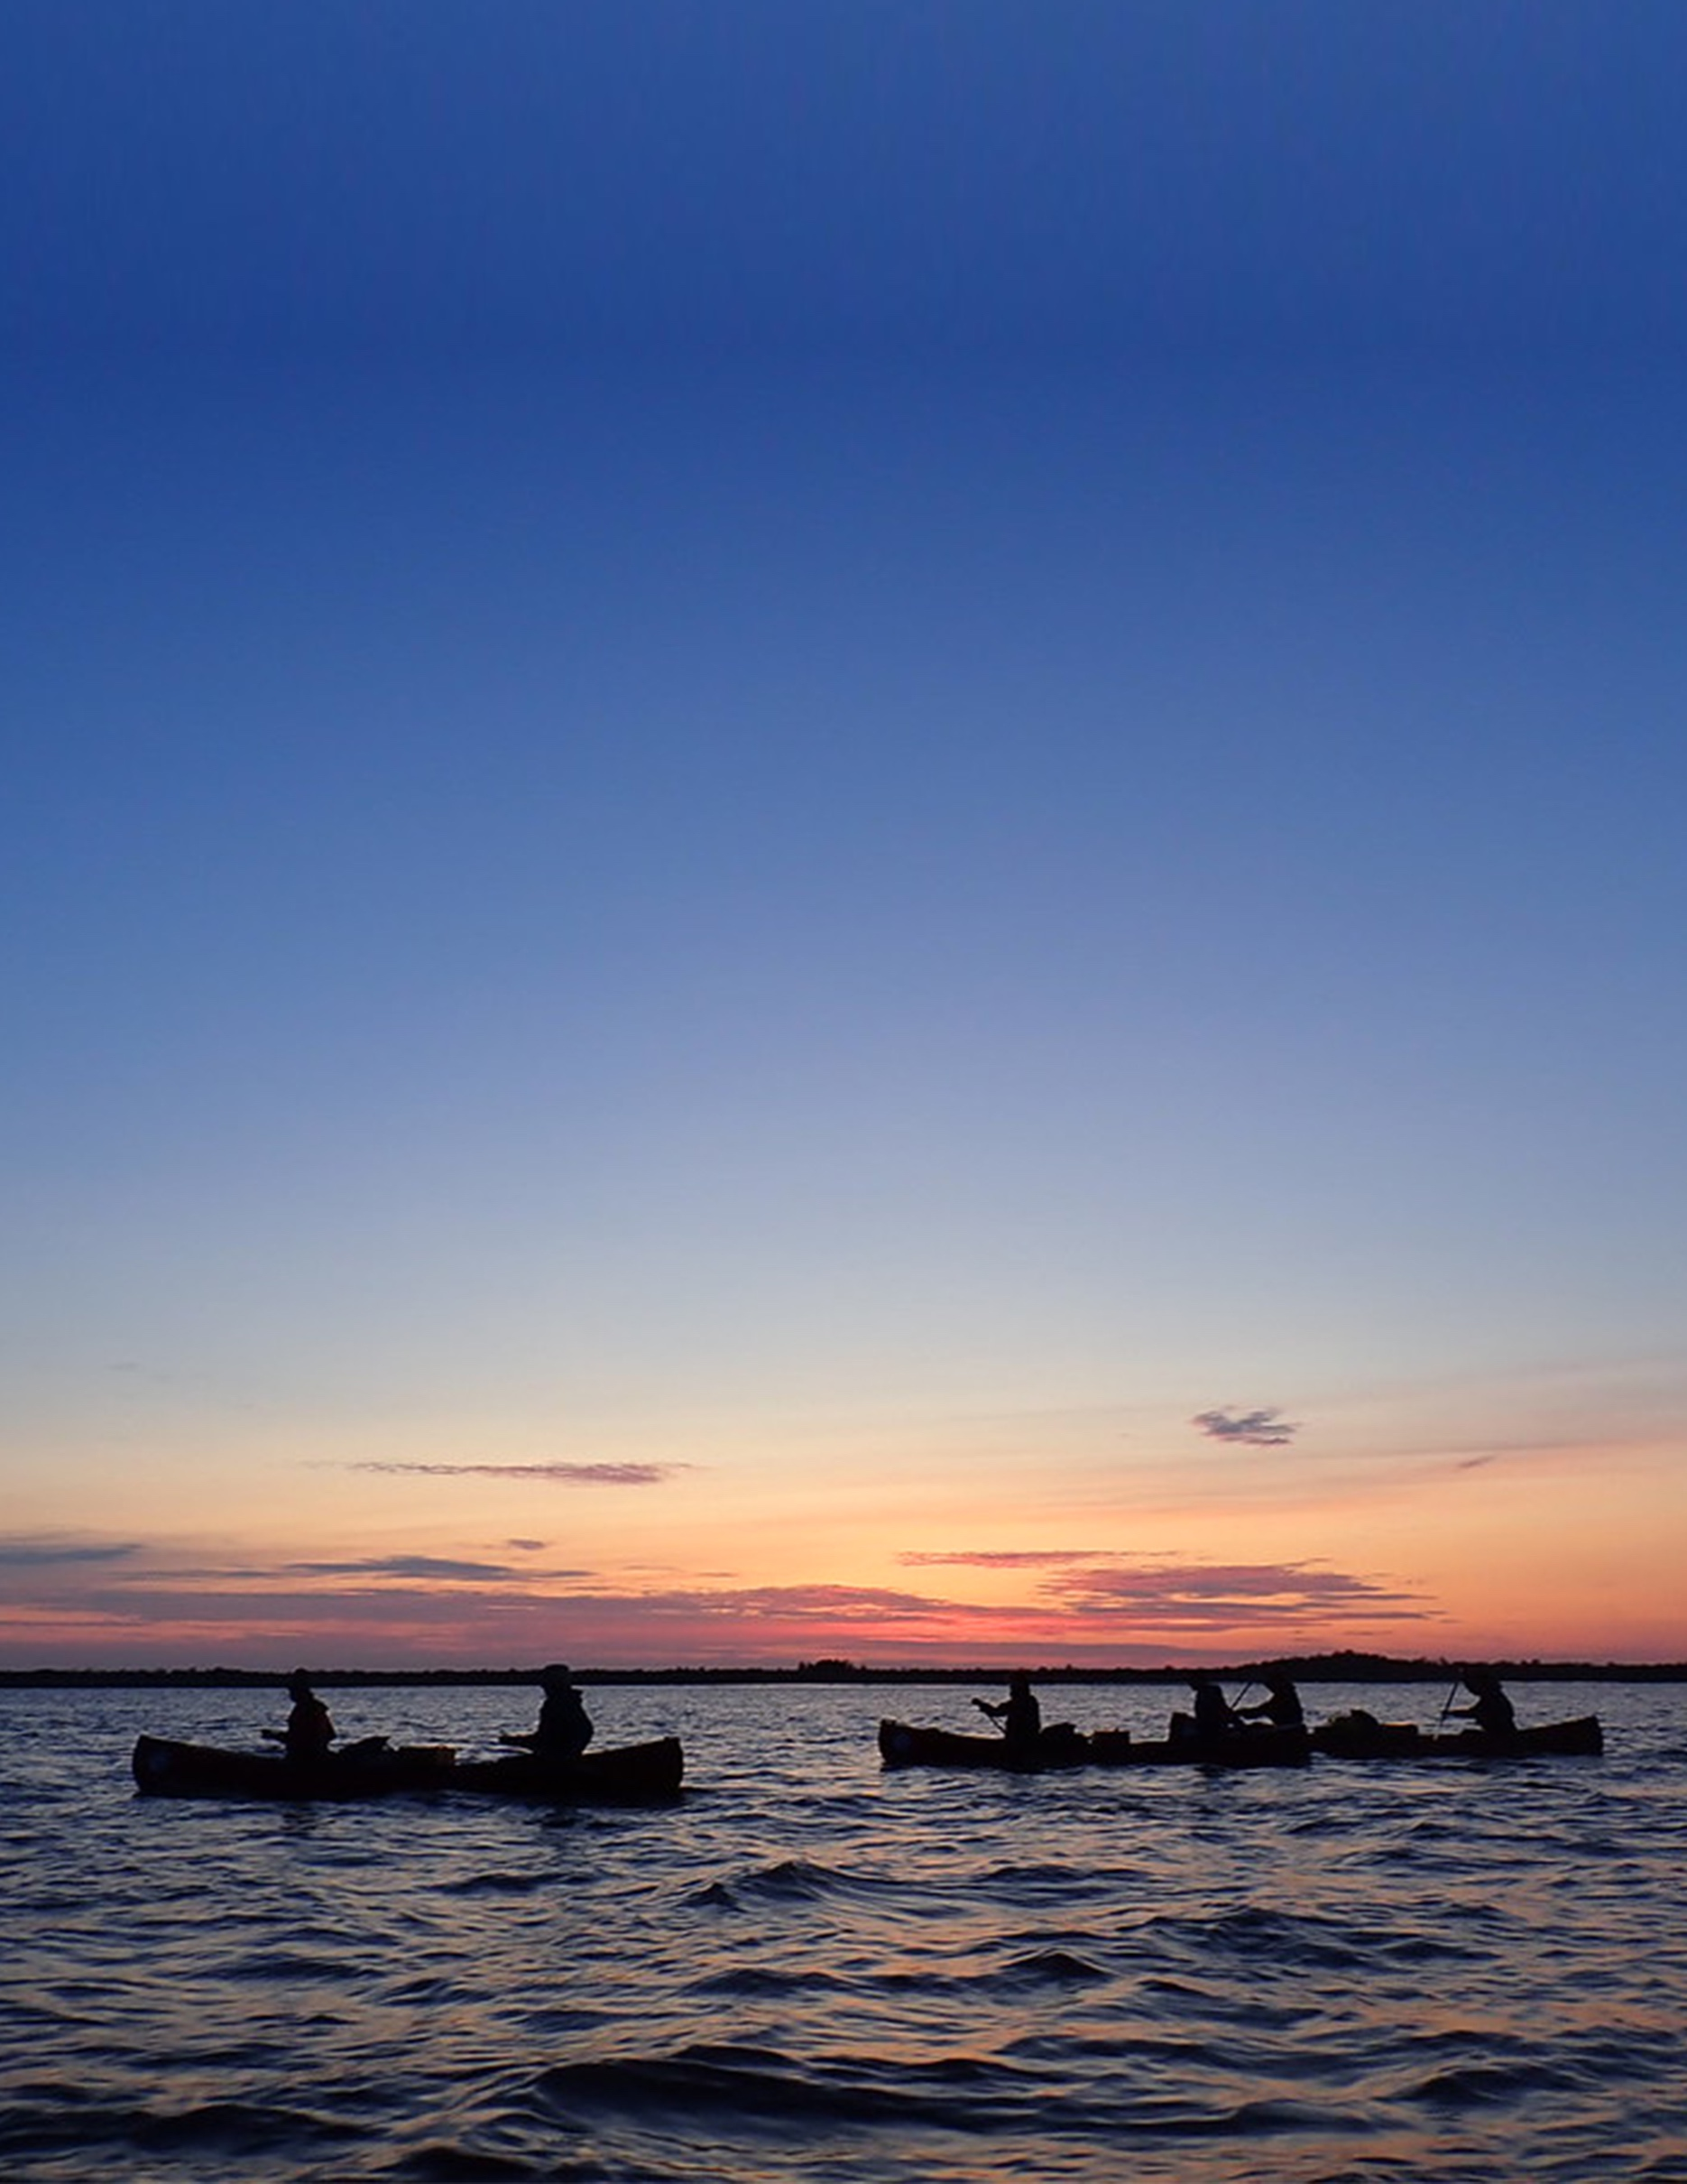

“If you trust in nature, in the small things that hardly anyone sees and that can so suddenly become huge, immeasurable; if you have this love for what is humble and try very simply, as someone who serves, to win the confidence of what seems poor: then everything will become easier.”

- Rainer Maria Rilke

Overnight

At the outset of each year, students will embark on an overnight trip. This trip will be an opportunity for instructors to teach simple outdoor skills like how to set up camp. However, the trip's primary focus will be to establish community norms, nurture the beginnings of relationships between classmates and instructors, and give students a positive first experience out in the woods. Instructors will facilitate specific designs that allow students to get to know each other. There will be ample time for games, structured and unstructured. Dinner will be a delicious, comforting meal in celebration of the beginning of a year at school, in outdoor education and otherwise.

Learnings: camp setup, camp routine, gear management, water purification

Equipment Required: sleeping bags, sleeping pads, personal gear

Equipment Supplied: food, tents, cookware, tarps, first aid kit

Rentals Required: hiking packs

4

Natural History
Grade 7

Natural History is the study of plants and animals by observation. This lesson engages students with the world around them by giving them the skills required to identify basic flora and fauna. Students will also learn if organisms are native or invasive. They will then explore the outdoors through a scavenger hunt, which will require them to recognize and collect leaves, bark, and other plant life. Students will then change into their wet shoes to study life under the water! They will discuss the importance of waterways and learn about the role waterways play in the environment at large. Is this waterway healthy? How can we measure the health of an aquatic ecosystem? Using nets, students will collect riverbed samples, and using magnifying glasses, they will observe and measure the number of organisms collected as a way of assessing waterway health.

Learnings: tree identification, hardwood vs. softwood, native vs. invasive, river organism identification, river health indicators

Equipment Required: pen, paper, wet shoes
Equipment Supplied: nets, buckets, magnifying glasses, clip boards, first aid kit

5

Fire Starting
Grade 7

Fire-starting is an essential skill for any outdoor adventurer. This lesson teaches firewood collection and fire-starting techniques, beginning with students learning the critical elements needed to make fire: fuel, oxygen, and heat. They will learn to identify and gather fuel from the natural world, from tinder, to kindling, to more substantial fuel sources. Then they will practice building fires, using several construction techniques that allow for adequate airflow. Finally, they will light their fires! Students will be challenged to light fires using ignition methods of increasing difficulty from matches, to flint and steel, to magnifying glasses, to bow drills. Tea will be provided, and students will be able to make themselves a hot drink using their newly acquired skills.

Learnings: firewood identification, firewood gathering, fire starting (matches, flint and steel, magnifying glass, bow drill)

Equipment Required: warm clothes

Equipment Supplied: matches, flint & steel, magnifying glasses, bow drills, welders’ blankets, fire extinguishers, first aid kit

6

Knot Tying
Grade 7

Ropes are an essential tool for any outdoor adventure. With the right skills, they can be used for an almost endless variety of tasks, from something as simple as tying up a boat to something as complicated as scaling a mountain. First, students will learn about different types of rope, as well as their applications, focusing on things like build, gauge, and carrying capacity. Then they will learn three basic knots: the bowline, the clove hitch, and the truckers hitch. Finally, they will combine these knots into a rope system and learn how to hang tarps. These skills make it possible, with minimal equipment, to establish a basic shelter. Tarp integrity will be lovingly tested with a bucket of water!

Learnings: rope attributes, bowline, clove hitch, trucker’s hitch, tarp setup

Equipment Required: n/a

Equipment Supplied: rope, tarps, first aid kit

7

Voyageur Trip
Grade 7

The Voyageur Trip will be the first expedition students undertake during the program. Voyageur canoes seat twelve paddlers and are an excellent introduction to the world of canoe tripping. They allow instructors to keep novice paddlers together on open water, and are incredibly stable, even in adverse weather conditions. This trip will focus on teaching students the basic routines of expeditionary travel. Every day students will wake up, prepare and eat breakfast, pack up camp, paddle for the bulk of the day, and then make camp. That evening they will prepare lunch and dinner for the following day and go to sleep under the stars. Throughout the trip, there will be ample time for exploration, play, and adventure as it presents itself. Students will also have opportunities to apply the skills they've acquired throughout the year: natural history, fire-starting, and knot tying will be used daily.

Learnings: voyageur canoeing, camp setup, camp routine, cooking, gear management

Equipment Required: sleeping bags, sleeping pads, personal gear

Equipment Supplied: food, voyageur canoes, paddles, life jackets, tents, cookware, tarps, maps, dry bags, first aid kit

8

Maps & Orienteering
Grade 8

Whether in an urban setting or on a remote expedition, being able to read a map is an invaluable ability. This lesson will start by teaching map basics, including an explanation of the cardinal directions, legends, and topography. Then, using a compass, students will learn how to travel using bearings. Once comfortable with these skills, it will be time to head outside! Working together in small groups, students will navigate, on and off trail, using their map and compass to gather clues to a riddle. These skills, while less commonplace today, are still a useful foundation in understanding and navigating using modern, GPS driven applications.

Learnings: basic map reading, taking bearings

Equipment Required: n/a

Equipment Supplied: maps, compasses, plastic cones, first aid kit

9

Axe & Saw
Grade 8

Because of their versatility axes and saws are an indispensable part of any adventurists' outfit. They are, however, potentially dangerous, and require responsibility and skill to use safely and effectively. Their risk demands that students focus and that instructors trust in their students' maturity. Because of this, it is exhilarating for young people to learn how to use them. It is powerful for adolescents to feel the trust of an adult, and to trust themselves.

This lesson will teach firewood collection and simple structure building. Students will learn to fell, limb, buck, and split a tree into usable fuel. Contact splitting, a low-risk technique, will be used to split rounds into firewood and kindling. Then, students will use tree limbs to build a tripod. Students will then start a small fire with their freshly gathered firewood and prepare a hot drink using a tripod to support a pot of water over the fire.

Learnings: axe and saw basics, felling, limbing, bucking, contact splitting, tripod construction

Equipment Required: n/a
Equipment Supplied: axes, saws, paracord, first aid kit

10

Paddle Training
Grade 8

In preparation for their Grade 8 expedition, this lesson will teach the basics of paddling a two-person canoe. All students will practice strokes in both the bow and stern positions, covering basic strokes (forward paddle, back paddle, and draw and cross-draw strokes), corrective strokes (j-strokes and rudder strokes), and a few more advanced strokes (braces and skulls). Students will also learn how to sit in a canoe to increase stability, and how to right a capsized canoe. This outing will include a short paddle to increase students' general comfort being in a canoe.

Learnings: canoe strokes, t-rescues, canoe care

Equipment Required: wet clothes, dry clothes

Equipment Supplied: canoes, paddles, life jackets, first aid kit

11

Algonquin Trip
Grade 8

With the experience of a voyageur canoe trip and two years of outdoor skills training, Grade 8 students will be ready to culminate their middle school experience with a canoe trip in Algonquin Park. As their first trip in tandem canoes, this expedition will introduce new and exciting challenges. Portaging will be introduced, proving to be a demanding, but rewarding experience as students can access more remote parts of Ontario's Algonquin Park. While the expedition's daily routine will be familiar, more responsibility will be given to students as they manage their own boats and equipment. It will be an adventure to remember in Canada's most iconic canoeing destination!

Learnings: canoeing, portaging, cooking, gear management

Equipment Required: sleeping bags, sleeping pads, personal gear

Equipment Supplied: food, canoes, paddles, life jackets, tents, cookware, tarps, maps, dry bags, first aid kit

12

Return & Recognition

In our open enrollment programs, one of our tenets is celebrating our participants upon their return from the land. In rising to the demands of wilderness travel, our participants discover in themselves new strengths, abilities, and insights. We have found it invaluable to allow them to share those discoveries. To this end, we host BBQ gatherings, to which we invite parents and family. During these celebrations, each trip and each participant speaks to the heart and meaning of their experience. Their articulation helps them reflect on how they have changed. Their families witness this change, which allows them to see, and therefore treat, their children differently. We believe this process, of both the individual and the family recognizing change, is an essential step in the process of a young person growing up.

These celebrations are also an opportunity for our many trips to share stories amongst each other. Our younger trips look to our older participants as role models. Our older trips, in response, rise to the occasion and make themselves worthy of such admiration. Our younger trips are inspired, and dream of embarking on longer, more remote adventures. Our older trips feel recognized, rightfully so, and feel a deep sense of accomplishment.

We will organize a similar celebration at the end of each year. We will invite family and friends. We will serve food, prepared with the help of students. We will share pictures (a slideshow!) and stories. We will gather, and each trip and each student will speak to the heart and meaning of their experience.

13

“Everyone must believe in something. I believe I’ll go canoeing.”
- Henry David Thoreau

